 |  |  |  | CARTON RATIO |  | c12 |  |  |  |  | 1 | 2 | 3 | 3 | 2 | 1
 |  |  |  | CARTON RATIO |  | d12 | 1 | 2 | 3 | 3 | 2 | 1
Photos | Code | Colour | Colour | Assortment | Cartons | Pairs | 36 | 37 | 38 | 39 | 40 | 41 | 42 | 43 | 44 | 45
 | DYON4154S7/C1A | B lac k | B lac k | D12 USPA | 42 | 504 | 42 | 84 | 126 | 126 | 84 | 42 | 0 | 0 | 0 | 0
 | DYON4154S7/C1A | Dk Black | Dk Black | D12 USPA | 35 | 420 | 35 | 70 | 105 | 105 | 70 | 35 | 0 | 0 | 0 | 0
 | DYON4154S7/C1A | White | White | D12 USPA | 39 | 468 | 39 | 78 | 117 | 117 | 78 | 39 | 0 | 0 | 0 | 0
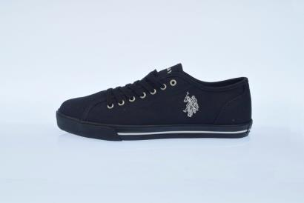
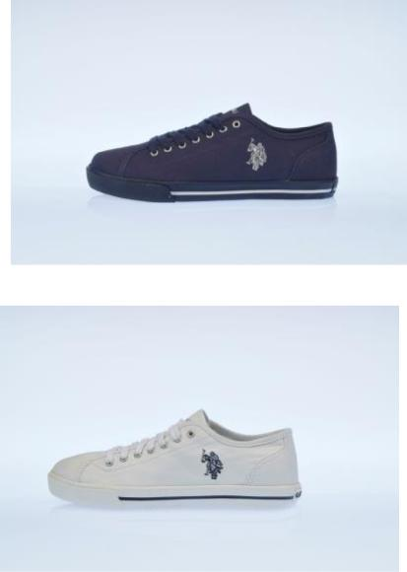
 | MARCS4137S7E/C2 | B lac k | B lac k | C12 USPA | 51 | 612 |  |  |  |  | 51 | 102 | 153 | 153 | 102 | 51
 | MARCS4137S7E/C2 | Dk Black | Dk Black | C12 USPA | 58 | 696 |  |  |  |  | 58 | 116 | 174 | 174 | 116 | 58
 | MARCS4137S7E/C2 | WHI | WHI | C12 USPA | 63 | 756 |  |  |  |  | 63 | 126 | 189 | 189 | 126 | 63
 | NOBIL4044S6E/NH4 | BLK | BLK | C12 USPA | 56 | 672 |  |  |  |  | 56 | 112 | 168 | 168 | 112 | 56
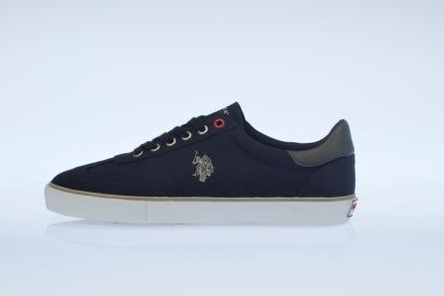
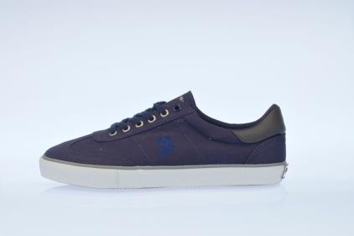
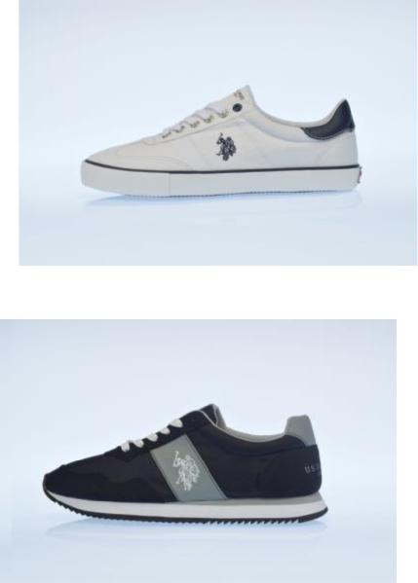
 | NOB IL 4044S6E/NH4 | DK B L | DK B L | C12 USPA | 34 | 408 |  |  |  |  | 34 | 68 | 102 | 102 | 68 | 34
 | NOBIL4044S6E/NH4 | LIBL | LIBL | C12 USPA | 72 | 864 |  |  |  |  | 72 | 144 | 216 | 216 | 144 | 72
 | NOBIL4044S6E/NH4 | WHI | WHI | C12 USPA | 24 | 288 |  |  |  |  | 24 | 48 | 72 | 72 | 48 | 24
 | NOBIL4241S7E/CH1 | AVIO | AVIO | C12 USPA | 112 | 1344 |  |  |  |  | 112 | 224 | 336 | 336 | 224 | 112
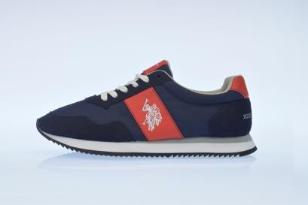
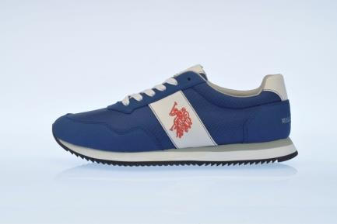
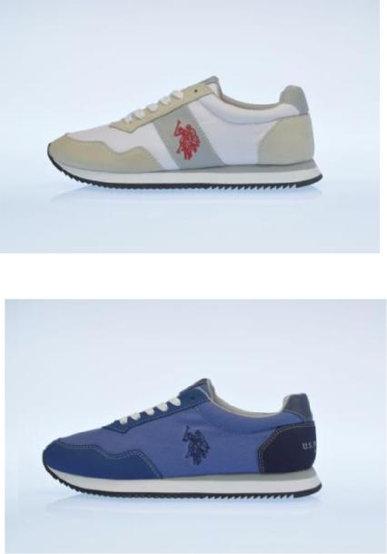
 | NOB IL 4241S7E/CH1 | Dk Black | Dk Black | C12 USPA | 66 | 792 |  |  |  |  | 66 | 132 | 198 | 198 | 132 | 66
 | NOBIL4241S7E/CH1 | Grfeen | Green | C12 USPA | 96 | 1152 |  |  |  |  | 96 | 192 | 288 | 288 | 192 | 96
 | NOBIL4241S7E/CH1 | Yellow | Yellow | C12 USPA | 95 | 1140 |  |  |  |  | 95 | 190 | 285 | 285 | 190 | 95
 | NOBIW4197S6E/NH4 | LIBL | LIBL | D12 USPA | 28 | 336 | 28 | 56 | 84 | 84 | 56 | 28 | 0 | 0 | 0 | 0
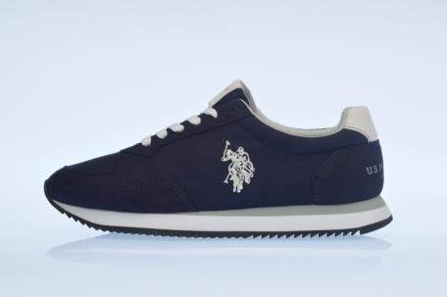
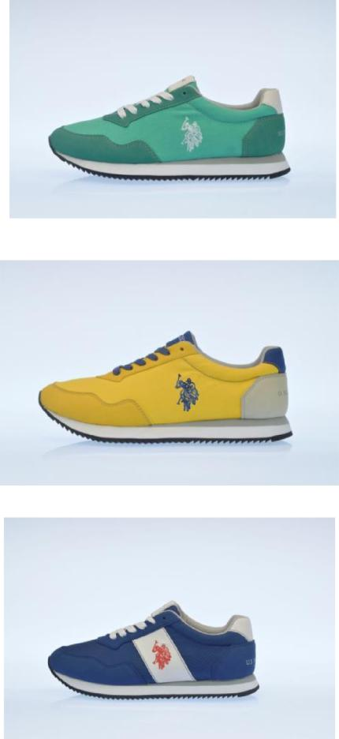
 | NOB IW4197S6E/NH4 | RED | RED | D12 USPA | 42 | 504 | 42 | 84 | 126 | 126 | 84 | 42 | 0 | 0 | 0 | 0
 | NOBIW4197S6E/NH4 | WHI | WHI | D12 USPA | 51 | 612 | 51 | 102 | 153 | 153 | 102 | 51 | 0 | 0 | 0 | 0
 | NOBIW4243S7E/CH1 | DK BL | DK BL | D12 USPA | 32 | 384 | 32 | 64 | 96 | 96 | 64 | 32 | 0 | 0 | 0 | 0
 | NOBIW4243S7E/CH1 | FUX | FUX | D12 USPA | 43 | 516 | 43 | 86 | 129 | 129 | 86 | 43 | 0 | 0 | 0 | 0
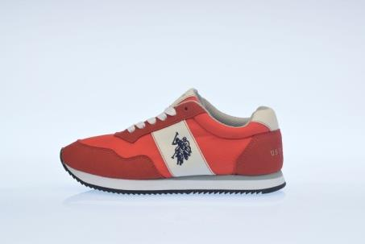
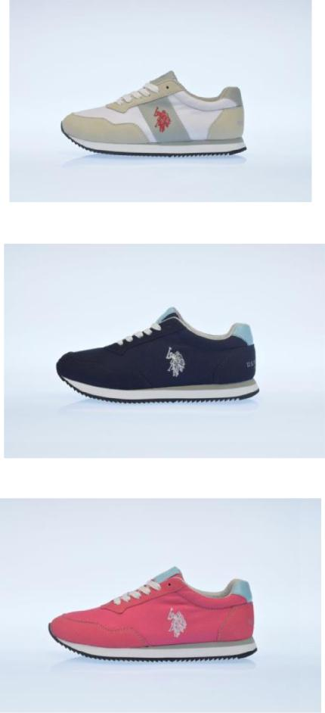
 | NOB IW4243S7E/CH1 | WHI | WHI | D12 USPA | 37 | 444 | 37 | 74 | 111 | 111 | 74 | 37 | 0 | 0 | 0 | 0
 | GALAD4149S6/CY2 | BLK | BLK | D12 USPA | 48 | 576 | 48 | 96 | 144 | 144 | 96 | 48 | 0 | 0 | 0 | 0
 | GALAD4149S6/CY2 | DK BL | DK BL | D12 USPA | 48 | 576 | 48 | 96 | 144 | 144 | 96 | 48 | 0 | 0 | 0 | 0
 | GALAD4149S6/TY2A | AVIO | AVIO | D12 USPA | 53 | 636 | 53 | 106 | 159 | 159 | 106 | 53 | 0 | 0 | 0 | 0
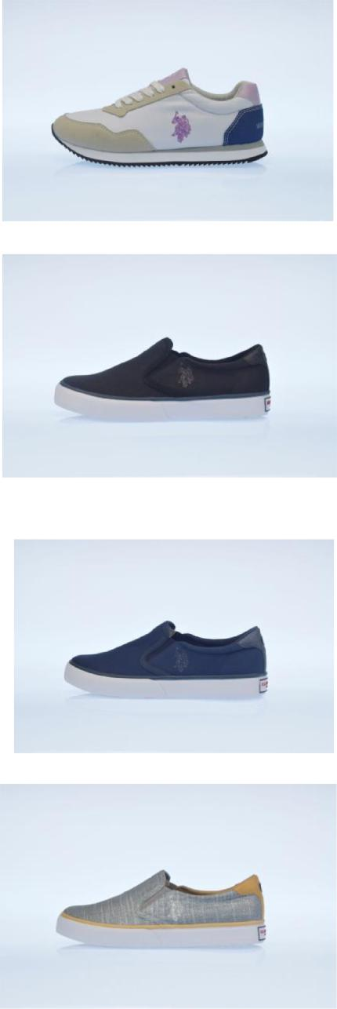
 | GAL AD4149S6/TY2A | IVORY | IVORY | D12 USPA | 52 | 624 | 52 | 104 | 156 | 156 | 104 | 52 | 0 | 0 | 0 | 0
 | GALAD4149S6/Y1A |  | BRON | D12 USPA | 13 | 156 | 13 | 26 | 39 | 39 | 26 | 13 | 0 | 0 | 0 | 0
 | GALAD4149S6/Y1A |  | SIL | D12 USPA | 20 | 240 | 20 | 40 | 60 | 60 | 40 | 20 | 0 | 0 | 0 | 0
 | GALAD4149S6/Y1A | PLAT | PLAT | D12 USPA | 38 | 456 | 38 | 76 | 114 | 114 | 76 | 38 | 0 | 0 | 0 | 0
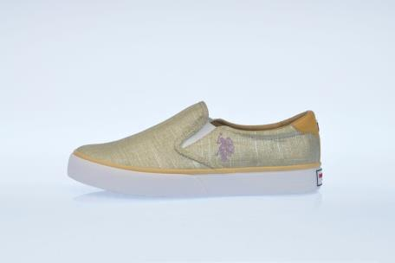
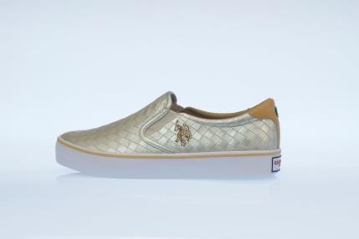
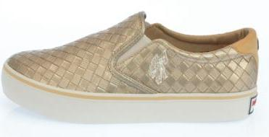
 | GAL AN4154S5/CL 9 | B L K | B L K | C12 USPA | 59 | 708 |  |  |  |  | 59 | 118 | 177 | 177 | 118 | 59
 | GALAN4154S5/CL9 | DKBL | DKBL | C12 USPA | 54 | 648 |  |  |  |  | 54 | 108 | 162 | 162 | 108 | 54
 | GALAN4154S5/CL9 | WHI | WHI | C12 USPA | 54 | 648 |  |  |  |  | 54 | 108 | 162 | 162 | 108 | 54
 | GALAN4317S3/CL12 | BLK | BLK | C12 USPA | 51 | 612 |  |  |  |  | 51 | 102 | 153 | 153 | 102 | 51
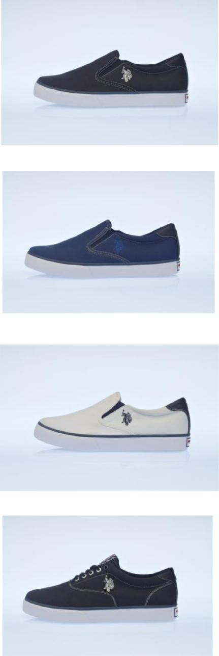
 | GAL AN4317S3/CL 12 | DK B L | DK B L | C12 USPA | 51 | 612 |  |  |  |  | 51 | 102 | 153 | 153 | 102 | 51
 | GALAN4317S3/CL12 | WHI | WHI | C12 USPA | 51 | 612 |  |  |  |  | 51 | 102 | 153 | 153 | 102 | 51
 | GYNN4238S7/T1 |  | DKBL | C12 USPA | 25 | 300 |  |  |  |  | 25 | 50 | 75 | 75 | 50 | 25
 | GYNN4238S7/C1 | WHI | WHI | C12 USPA | 49 | 588 |  |  |  |  | 49 | 98 | 147 | 147 | 98 | 49
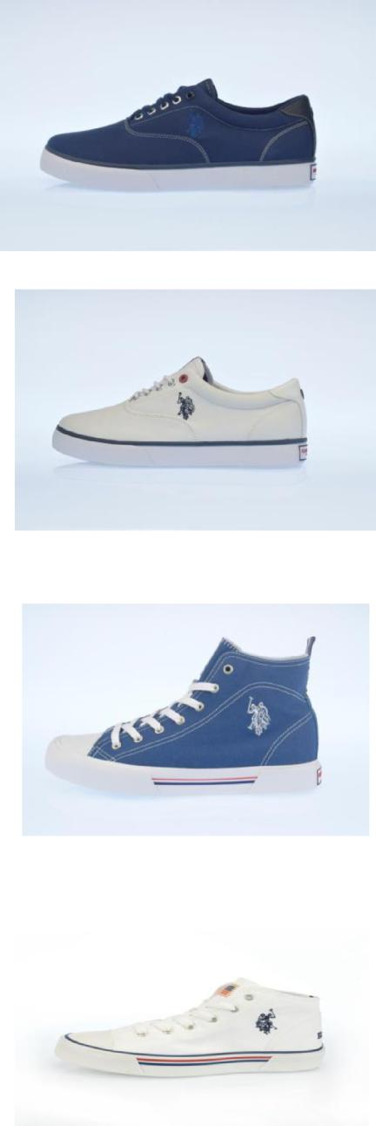
 | GYNN4238S7/C1 | GREY | GREY | C12 USPA | 30 | 360 |  |  |  |  | 30 | 60 | 90 | 90 | 60 | 30
 | GYNN4238S7/C1 |  | DKBL | C12 USPA | 19 | 228 |  |  |  |  | 19 | 38 | 57 | 57 | 38 | 19
 | GYNN4238S7/C1 | BLK | BLK | C12 USPA | 44 | 528 |  |  |  |  | 44 | 88 | 132 | 132 | 88 | 44
 | GYNN4238S7/C1 | RED | RED | C12 USPA | 60 | 720 |  |  |  |  | 60 | 120 | 180 | 180 | 120 | 60
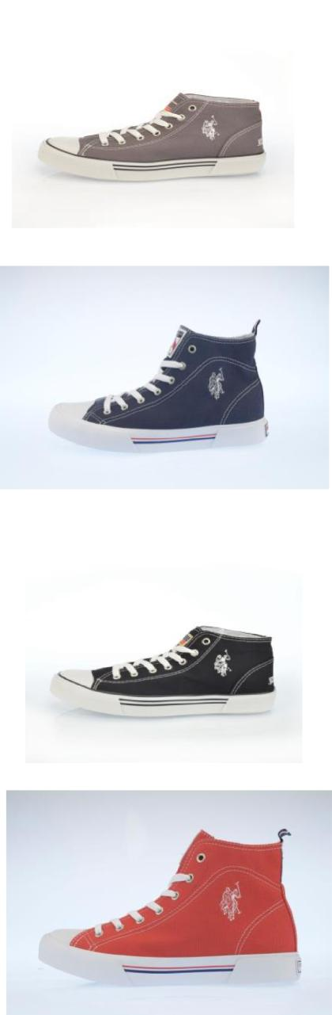
 | GYNN4239S7/T1 |  | DK B L | C12 USPA | 21 | 252 |  |  |  |  | 21 | 42 | 63 | 63 | 42 | 21
 | GYNN4239S7/C1 | WHI | WHI | C12 USPA | 51 | 612 |  |  |  |  | 51 | 102 | 153 | 153 | 102 | 51
 | GYNN4239S7/C1 | GREY | GREY | C12 USPA | 33 | 396 |  |  |  |  | 33 | 66 | 99 | 99 | 66 | 33
 | GYNN4239S7/C1 | DKBL | DKBL | C12 USPA | 25 | 300 |  |  |  |  | 25 | 50 | 75 | 75 | 50 | 25
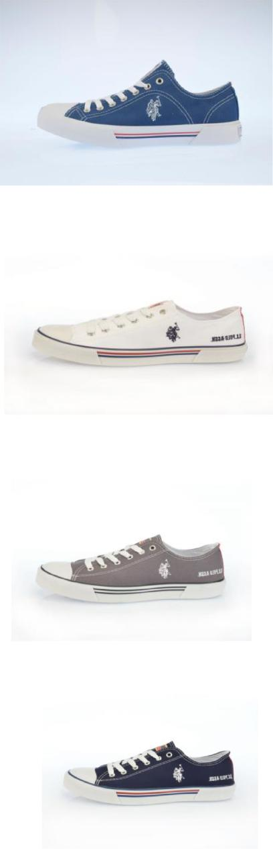
 | GYNN4239S7/C1 | B L K | B L K | C12 USPA | 55 | 660 |  |  |  |  | 55 | 110 | 165 | 165 | 110 | 55
 | GYNN4239S7/C1 | RED | RED | C12 USPA | 60 | 720 |  |  |  |  | 60 | 120 | 180 | 180 | 120 | 60
 | GYNNA4240S7/T1 |  | DKBL | D12 USPA | 30 | 360 | 30 | 60 | 90 | 90 | 60 | 30 | 0 | 0 | 0 | 0
 | GYNNA4240S7/C1 | WHI | WHI | D12 USPA | 28 | 336 | 28 | 56 | 84 | 84 | 56 | 28 | 0 | 0 | 0 | 0
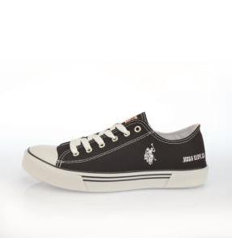
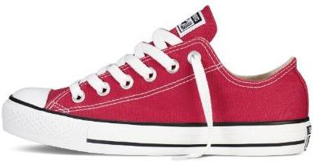
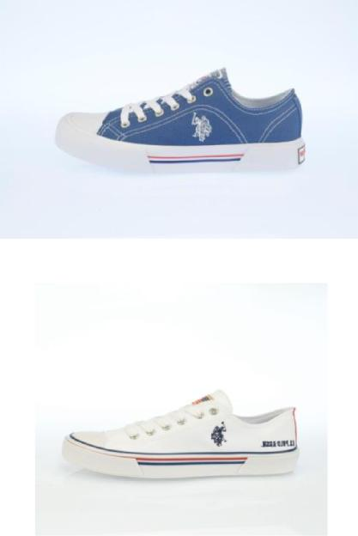
 | GYNNA4240S7/C1 | DK B L | DK B L | D12 USPA | 25 | 300 | 25 | 50 | 75 | 75 | 50 | 25 | 0 | 0 | 0 | 0
 | GYNNA4240S7/C1 | BLK | BLK | D12 USPA | 30 | 360 | 30 | 60 | 90 | 90 | 60 | 30 | 0 | 0 | 0 | 0
 | GYNNA4240S7/C1 | RED | RED | D12 USPA | 32 | 384 | 32 | 64 | 96 | 96 | 64 | 32 | 0 | 0 | 0 | 0
 | GYNNA4240S7/C1 |  | PINK | D12 USPA | 25 | 300 | 25 | 50 | 75 | 75 | 50 | 25 | 0 | 0 | 0 | 0
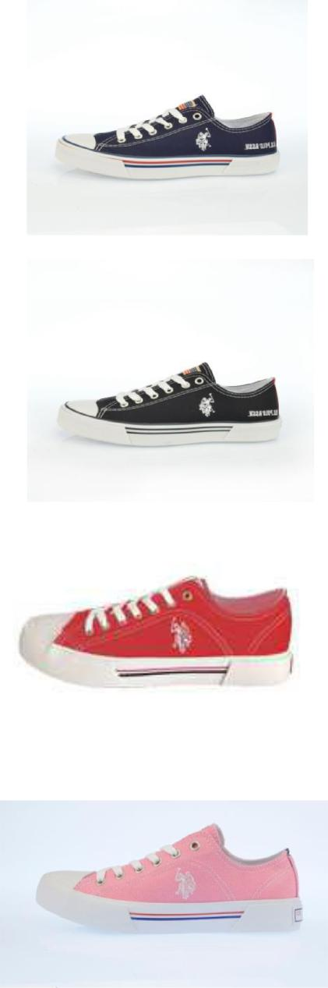
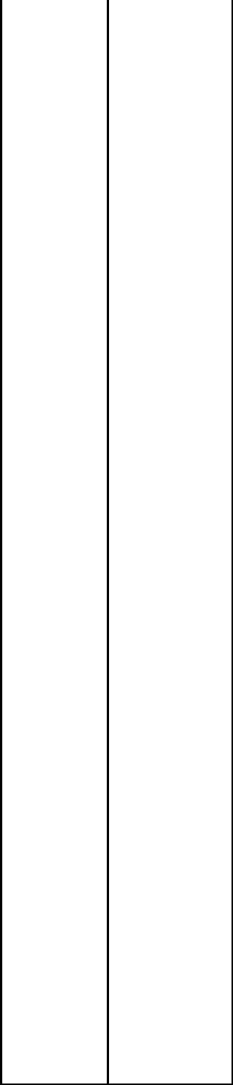 | GYNNA4240S7/T1 | WHI | WHI | D12 USPA | 77 | 924 | 77 | 154 | 231 | 231 | 154 | 77 | 0 | 0 | 0 | 0
 | GYNNA4240S7/T1 | BLK | BLK | D12 USPA | 58 | 696 | 58 | 116 | 174 | 174 | 116 | 58 | 0 | 0 | 0 | 0
 | GYNNA4240S7/T1 | RED | RED | D12 USPA | 79 | 948 | 79 | 158 | 237 | 237 | 158 | 79 | 0 | 0 | 0 | 0
 | GYNNA4240S7/T1 |  | PINK | D12 USPA | 37 | 444 | 37 | 74 | 111 | 111 | 74 | 37 | 0 | 0 | 0 | 0
 |  |  |  |  | 2561 | 30732
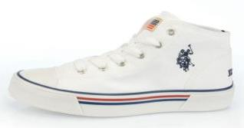
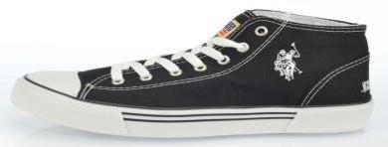
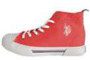
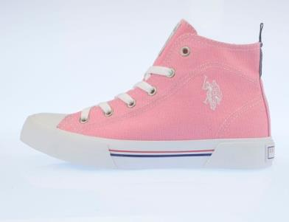
PLEASE NOTE THAT THE STOCK IS SOLD IN CARTONS OF 12 PAIRS

THE RATIO IS AS ABOVE EITHER C12 OR D12

